**Part 1**

import java.awt.BasicStroke;

import java.awt.Color;

import java.awt.Graphics2D;

public class Part1 {

public static void main(String[] args) {

DrawingPanel panel = new DrawingPanel(300, 300);

panel.setBackground(Color.WHITE);

Graphics2D g = panel.getGraphics();

g.setColor(new Color(237,28,36));

g.fillOval(75, 75, 150, 150);

g.setColor(Color.WHITE);

g.setStroke(new BasicStroke(12));

g.drawOval(112,112 ,75 ,75 );

g.fillRect(106, 75, 12, 75);

}

}

Output

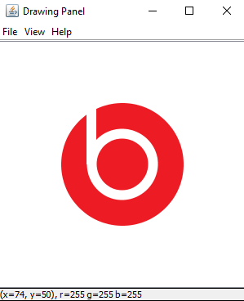

**Part 2**

import java.awt.Color;

import java.awt.Font;

import java.awt.Graphics2D;

public class Part1 {

public static void main(String[] args) {

DrawingPanel panel = new DrawingPanel(300, 300);

Graphics2D g = panel.getGraphics();

g.setColor(new Color(242,80,34));

g.fillRect(50, 50, 50, 50);

g.setColor( new Color(127,186,0));

g.fillRect(100, 50, 50, 50);

g.setColor(new Color(1,164,239));

g.fillRect(50, 100, 50, 50);

g.setColor(new Color(255,185,1));

g.fillRect(100, 100, 50, 50);

g.setColor(Color.WHITE);

g.fillRect(98, 50, 4, 100);

g.fillRect(50, 98, 100, 4);

g.setColor(new Color(117,117,117));

g.setFont(new Font("Helvetica", Font.PLAIN, 20));

g.drawString("Microsoft", 60 , 170);

}

}

